Transportation Planning to Accommodate Needs of Wind Energy Projects

Sebastian Astroza
The University of Texas at Austin
Department of Civil, Architectural and Environmental Engineering
301 E. Dean Keeton St. Stop C1761, Austin, TX 78712, USA
Phone: 1-512-471-4535, Fax: 1-512-475-8744
Email: sastroza@utexas.edu

Priyadarshan N. Patil
The University of Texas at Austin
Department of Civil, Architectural and Environmental Engineering
301 E. Dean Keeton St. Stop C1761, Austin, TX 78712, USA
Phone: 1-512-471-4535, Fax: 1-512-475-8744
Email: priyadarshan@utexas.edu

Katherine I. Smith
The University of Texas at Austin
Department of Civil, Architectural and Environmental Engineering
301 E. Dean Keeton St. Stop C1761, Austin, TX 78712, USA
Phone: 1-512-471-4535, Fax: 1-512-475-8744
Email: katherine.smith@utexas.edu

Chandra R. Bhat (corresponding author)
The University of Texas at Austin
Department of Civil, Architectural and Environmental Engineering
301 E. Dean Keeton St. Stop C1761, Austin, TX 78712, USA
Phone: 1-512-471-4535, Fax: 1-512-475-8744
Email: bhat@mail.utexas.edu
and
The Hong Kong Polytechnic University, Hung Hom, Kowloon, Hong Kong

ABSTRACT
Given the upward trend in wind energy production in Texas, this paper proposes a methodology and an associated operational planning tool that can be used to develop optimal route plans for the transportation of wind turbine components on Texas roadways. In addition, the paper provides recommendations for transportation infrastructure maintenance and upgrade strategies, as well as for more general multi-sector infrastructure improvements needed, in response to the predicted growth of wind energy over time. Specifically, as part of this research, we predict the amount of energy that will be installed in Texas from 2015 to 2025 and we use our tool, along with detailed knowledge of the wind energy production industry and the related supply chain, to find the optimal routes for the wind turbine components (minimizing both potential for road damage and driver delay). We also propose a methodology to use our tool for the analysis of several “what-if?” scenarios. The tool and the associated methodology, while developed for Texas, can be generalized to any other state, after updating the underlying databases.

Keywords: Wind energy production, planning tool, wind turbine components transportation, renewable energy, route planning.

1. INTRODUCTION
1.1. Background
Texas is the top state in the U.S. in wind energy production, and has more than 8000 MW of wind power capacity currently under construction (1). Texas’s success in installed wind power capacity is partially attributable to the Renewable Portfolio Standard (RPS) (2). The Texas legislature first introduced the RPS in 1999 under Senate Bill 7 to ensure continuous growth in the state’s renewable energy generation, despite the increasing competitiveness in the electricity market. RPS mandated that electricity providers generate 2000 MW of additional renewable energy by 2009. This 10-year target was met in 6 years. Then Senate Bill 20 was introduced in 2005, mandating that the state’s total renewable energy generation must reach 5880 MW and 10000 MW by 2015 and 2025, respectively. Since creation of the RPS, Texas wind power development has more than quadrupled. Because of its competitive pricing, available federal tax incentives, and abundance of capturable wind capacity, wind power is expected to remain competitive with coal-fired plants (3). Another important contributor to the rapid expansion of Texas wind power energy is the state’s plan for the installation of transmission lines (4) and laws that make transmission inexpensive for the developers of wind power energy. The Public Utility Commission (PUC) of Texas identified the top 25 wind regions and completed almost 3,600 circuit miles of new transmission lines by the end of 2013, connecting the Panhandle, Central West Texas, and Central Texas. Most new wind farms will likely locate according to this plan, since the developers are not required to make a significant investment in transmission.
The rapid growth of wind energy production in Texas, however, has created a challenge for the roadway system. The construction of wind farms requires the transport of wind turbine components that create increased and unexpected loads on rural roads and bridges, which are typically not designed for such loads. Thus, the continued and increasing construction of wind farms will result in a greater burden on the state’s transportation infrastructure. Bridges, tunnels, tightly bending roads, signals, roadside signs, and markings are common navigation challenges for the trucks carrying extra-large oversize/overweight (OS/OW) loads to remote wind farm sites. Drivers of OS/OW loads cannot take the most direct route to their destinations because of highway impediments, such as sharp turning radii that cannot accommodate the load length or overpasses with insufficient vertical clearance. The long blades, heavy nacelles, and huge tower sections are considered “super loads” by transport authorities, so transporting them from manufacturers to wind farms requires close cooperation between manufacturers, shippers, state transport officials, and port authorities. Moving one wind turbine, with all the components involved, takes eight to ten trucks, most of which are specialized trailers, and requires OS/OW permits. At the same time, these OS/OW loads can damage infrastructure elements, creating serious safety concerns for other vehicles and drivers as well as the need for expensive repairs.
Due to the steep costs of transporting components, new manufacturers will set up their manufacturing plants as close as possible to wind farm locations (where the wind is actually harvested and transformed into energy). Many international manufacturers ship their components to major Texas Gulf ports such as Houston and Corpus Christi, where the components begin journeys of sometimes hundreds of miles to remote wind farm sites. Wind turbine components also enter the state through land entry points in either East or West Texas. Many domestic manufacturers also use the Texas road system as a throughway for cross-country traffic. Texas has to improve and maintain its road system to allow the transportation of increasingly larger and heavier loads related to wind farm development.
In summary, preparing the Texas transportation network for future wind farm installations is essential. Given the upward trend in wind energy production, the Texas Department of Transportation (TxDOT) is planning for the impacts of future renewable energy projects on roads, while facilitating the development of new renewable projects in and around Texas. This paper discusses the development of a methodology and a corresponding operational planning tool that TxDOT can use to propose route plans for wind turbine components transported on Texas roadways, develop recommendations for planning construction of new wind farms, and generate road maintenance strategies. With a well-designed plan for transporting wind turbine components across Texas roads, truck drivers can use easier and more direct routes, wind energy developers can reduce costs, and state authorities can reduce investment in road maintenance and repair, while the entire state and country can stand to gain from the use of this promising renewable energy source.

1.2. Antecedents
Wind turbine sizes have increased significantly over the past decades, for both technical and economic reasons. According to aerodynamic properties, the power output of a wind turbine is proportional to the rotor diameter and the wind speed. As the distance from the ground increases, wind becomes less turbulent and reaches higher speeds, which means that both an increase in the rotor diameter and in the tower height can increase the energy yield of the turbine. From a cost perspective, bigger components generate more energy and also have a lower ratio of installation and maintenance cost per unit of energy produced, allowing for economies of scale and faster return on investment (see 5). Even at their current size, however, transporting the already OS/OW components is a complicated endeavor for manufacturers and transportation authorities.
A major impediment in the process of shipping OS/OW loads is the distribution of permits from state agencies. In Texas, the Department of Motor Vehicles (DMV) issues OS/OW permits. Systems without automated processes cause delays due to the labor-intensive nature of the work, which is further subject to human error. Advanced routing and permitting systems (ARPS) have become increasingly popular as they increase efficiency and allow a route to be issued at any time. Many states (6) now employ ARPS to issue the OS/OW permits and routes needed for transporting wind turbine components. The majority of automated systems use a variety of regularly updated GIS maps containing pertinent route characteristics, such as bridge height, turning radii at intersections, and roadway lane widths. Currently the Texas DMV uses a web-based, integrated, GIS-based mapping system with real-time restriction management (referred to as the Texas Permitting & Routing Optimization System or TxPROS). Shippers can log in to TxPROS and use the “Permit Wizard” to determine the permit type and route required for a particular vehicle or load. Route plan formulation has various levels of automation, with most based on an algorithm. If a route is self-chosen and any section of the route fails, the permit request will not go through—either the program will terminate or the algorithm will correct the route and explain the reason behind the reroute.
A significant challenge in the transportation of wind turbine components is the recognition of critical points in the route—locations where the roadway or bridge characteristics cannot allow the caravan to pass. Critical points will cause user-input routes to be rejected if they are found. Such infrastructure constraints include low bridge clearances, narrow bridge widths, and pavement strength issues, among other factors. To improve the efficiency of route planning, research initiatives have developed software and applications to detect critical points along route plans. As established, the increasing number of wind farms in Texas necessitates increased transportation of wind turbine components, which will cause early deterioration of roads and bridges. Tracking the wind-farm-related damage to infrastructure is essential for the health of the transportation economy, as OS/OW permit fee structures are designed in part to recoup the repair and maintenance expenditures. Banerjee et al. (7) proposed a methodology to quantify the damage done to Texas’s highway infrastructure during the movement of wind turbine components. Another Texas-specific tool implemented a GIS environment to map the routes that OS/OW loads took across Texas to estimate the cost of damage to the highway infrastructure (6). Similarly, a tool available for Minnesota roads is capable of estimating the monetary value of the turbine-related pavement damage using an Excel platform (8).

1.3. The Current Paper
The methodology and associated tool presented in this paper come at a critical time in the wind industry, as they provide a number of highly valued services that further optimize wind turbine transport. Previous tools focus on tour planning given an origin/destination pair; they are operational tools that provide, given truck and load dimensions, the best route solely in terms of distance. The tool we are presenting in the current paper contributes in two ways: (1) It improves upon route planning not only in terms of distance, but also considering the number of turns and pavement damage. Making a turn is a challenge when transporting turbine blades and tower sections, which are sometimes more than 100 feet long. Usually, routes must be scouted by an advance driver looking for sharp turns and obstructions such as stop signs that might need to be temporarily taken down. The trucks themselves are complex: a trailer with an independent back end is controlled remotely from a chase vehicle to allow the truck driver to make 90-degree turns, and each turn means several minutes of delay. In addition, the heavy loads of wind turbine components cause significant road deterioration, shortening the original life expectancy of pavement (7) and forcing authorities to invest in road repair instead of in transportation infrastructure improvement. (2) Our methodology and related tool also go beyond route planning, and collectively represent a multi-faceted planning system that can predict what transportation infrastructure will be needed based on our systematically researched predictions of wind energy growth. In the process of adding these predictive components, we also include the capability for performing “what-if” analysis. For example, the methodology and associated tool can be used to (a) determine the exact locations and types of road infrastructure improvements that would most improve the routing of wind turbine components, (b) identify how the continually changing technology of wind turbines will impact transportation planning, (c) determine the best locations to install a wind turbine manufacturing plant, (d) analyze how the country’s economic growth could influence wind energy production trends and the related transportation of components, (e) identify the best location for new electric transmission lines specific to wind power energy, and (f) evaluate what kind of improvements can be made to port-adjacent freight corridors and general infrastructure to optimize the path between the locations where wind turbine components are imported into and their inland destinations. In summary, the methodology and associated tool can be used not only by shippers that want to create the best routes for their needs and preferences, or by transportation agencies looking to strategize infrastructure repair and construction, but also by any public or private entity that wants to optimize planning of wind energy projects at the statewide level.

2. METHODOLOGY AND TOOL DEVELOPMENT
One of the key elements of our methodology is a routing tool that can help us to plan the future of wind turbine components transportation. We developed a tool that can map out a route between desired origin and destination points given certain characteristics, such as the size and load weight of a truck. The tool creates a route by optimizing the travel distance, number of turns, and potential pavement damage, while checking restrictions due to bridge clearances, postings, and pavement conditions. The tool was created in TransCAD and works as a TransCAD add-in.

2.1. Data Sources
We used four different datasets to create our TransCAD network: a map of the Texas road system, bridge characteristics, critical vertical clearance data, and pavement characteristics.

2.1.1. Road Network
The road network was extracted from the Texas Statewide Analysis Model (SAM) Version 3 developed by Alliance Transportation Group, Inc., for TxDOT. SAM is the primary tool for evaluating large intercity transportation projects throughout Texas. Although SAM has several functionalities, we are using only its network. After we disabled rail and air routes (thus removing them from the map), we used the SAM network as a base for our TransCAD network.

2.1.2 Bridge Data
The bridge dataset, obtained from TxDOT, includes detailed information about Texas highway bridges, providing information on bridge location (latitude/longitude), vertical clearance heights, structural characteristics contributing to an overall bridge condition rating, and the maximum allowable legal loads on the bridge. The latitude and longitude were used to locate the bridges geographically in the TransCAD map. The maximum load allowed can take one of the following values (in tons): 10, 15, 20, 25, or 100 (we assigned a high value to bridges that do not impose weight limitations, such as those records corresponding to routes that run “under” a structure).

2.1.3 Vertical Clearance Data for Signboards
Vertical clearance of signboards is an important factor in determining routes of OS loads along freight networks, as the clearance height limits the size of loads that can pass underneath. The vertical clearance dataset is a GIS map representing the Texas freight network, overlaid with vertical clearances of signboards as points along the network. The clearance height is specified in three levels: 16 to 18 feet, 14 to 16 feet, and under 14 feet. The ArcGIS online map is exported as a shapefile and then included in our TransCAD network.

2.1.4 Pavement Data
We pulled pavement data from the Texas Pavement Management Information System (PMIS). PMIS itemizes pavement characteristic data for the state-maintained highway system. The PMIS dataset includes condition summaries that provide specifics on ride quality, skids, structural strength, district control, management, automated rutting measurements, texture, and distresses in Portland cement concrete and asphalt concrete pavement, among many other parameters. PMIS provides easy access to various data about pavement conditions and quality throughout the Texas road network, which is useful in determining access routes for OS/OW loads. Our tool uses three PMIS variables: latitude, longitude (used to locate the pavement sectors in the TransCAD map), and condition score. Condition score combines the scores for ride quality and pavement distress, using a scale from 1 (worst condition) to 100 (best condition).

2.2. Routing Tool Function
We performed geographic analysis operations to combine the four datasets. Using the route network data as the base layer and the other data layers are geographically overlaid and the attributes matched to the base roads matching a given spatial threshold (0.05 miles for the bridge data, 0.25 miles for the vertical clearance data). The bridge dataset establishes the height and weight limits on the bridges, thus preventing their inclusion in routes generated for trucks carrying loads in excess of those limits. The vertical clearance data is then added to the roads on which they lie, to be used in restricting the number of paths considered in the shortest path algorithm. The pavement data is used to allot a certain score to the pavement, based on its current known condition.
The tool functions by calculating a composite score based on each road’s parameters and the constrained multi-objective shortest path algorithm. Users input the truck load, height, and configuration. The shortest path is the route with the lowest composite score. This composite score is computed in units of distance and is obtained as the weighted sum of the travel distance and a pavement condition measure, plus a penalty for each turn the truck makes. The weight of the travel distance and pavement condition have default values of 0.9 and 0.1 respectively, but those values can be modified by the user. The turn penalty has a default value of 5 miles per turn (for both right and left turns), but this value can also be modified by the user later (the default value is based on Clossey et al. (9), and Arkin et al. (10)). The default expression for the composite score corresponds to:

Composite Score = 0.9*Travel Distance in Miles + 0.1*Pavement Condition + 5*Number of turns (1)

The pavement condition measure is computed as Travel Distance * (100 - condition score)/100, using the condition score defined in Section 2.1.4. The pavement condition metric measures the existing pavement damage as reported by PMIS; roads with pavements in better condition contribute to lower, more favorable composite scores.
To use the tool, the user selects the origin and destination on the onscreen map of Texas. Employing a standard shortest path algorithm with turn movements and using the composite score as the optimization criteria, TransCAD calculates the optimum path and shows the user the route highlighted on the map, as well as providing detailed route instructions, such as the distances to be travelled on each road, road names, and intersections where turn movements are to be executed. This output is saved to a Notepad file.

3. PLANNING FOR THE FUTURE
Section 1.2 described ARPS applications that manufacturers or shipping companies can use to create a route plan for a given driver’s particular trip with an OS/OW load. As discussed in Section 1.3, our tool differs from these applications because: (1) it has a more general definition of the optimization criteria (minimizing both potential for road damage and driver delay), and (2) it can help to plan the future transportation of wind turbine components. To that end, we predict how much wind power energy will be installed in the state each year from 2016 to 2025. Then we use those predictions to compute the number of turbines to be installed and recommend the best way to transport them over the state roadway network.

3.1. Prediction Model
The first step in determining ideal routes for wind turbine component transportation throughout the state, and over time, is to identify future wind farm locations. This section describes the process of assembling the data and estimating a predictive model that we can use to forecast the number and location of new wind farms year-by-year through 2025.

3.1.1. Prediction Method
Our prediction methodology included the following steps:
- Texas was divided into 15,811 census block groups.
- For each zone (census block group), we collected information on several attributes that may impact the number of wind farms installed per year: distance from the centroid of each zone to the nearest urban road, distance from the centroid of each zone to the nearest primary electric transmission line, and the wind power potential of each zone.
- Based on information available online, we estimated the amount of wind power energy installed each year (from 1996 to 2015) in each zone.
- One record was created in our estimation sample for each year and each zone and the installed wind power energy was appended, as well as the other zone characteristics (see Step 2).
- A regression model was estimated using the records generated in the previous step.
- The parameters estimated in Step 5 were used to predict the amount of wind power energy that will be installed each year (from 2016 to 2025) in each zone.

3.1.2. Data Sources
Spatial GIS data was collected in the form of six main shapefiles, or digital map features: census block groups, wind farm locations, wind power potential, roads, transmission lines, and competitive renewable energy zones.
- From the U.S. census website, we downloaded the shapefile with the census block groups in Texas as a GIS polygon. The location of the centroid of each census block group was used to compute the distance to the nearest road and the nearest transmission line.
- The US Geological Survey, under the Data Series DS-817, provides a spreadsheet version of a dataset identifying windmill locations across the U.S.; this dataset includes manufacturers, windmill dimension and specification, years of operation, site name, etc. We filtered the data for Texas and found 7,715 valid windmill locations available with their exact latitude and longitude. The most recent data in the spreadsheet is from 2013. The locations of these windmills were entered in GIS for further estimation using the ‘locate X/Y’ tool in ArcMap.
- Wind farms constructed in 2014 and 2015 were addressed separately, as their exact locations are not in the public record. We had information about facility, county, and company name for the announced wind farms (the PUC maintains the dataset labeled “New Electric Generating Plants in Texas since 1995”). Using these keywords, we looked for any news articles and memoranda of understanding pertaining to the proposed location of these wind farms, as well as their respective county websites. Once there was some local information (e.g., 40 miles northeast of Amarillo), we used Google Maps to determine the latitude and longitude of that proposed facility. If the local information for the announced wind farm was not available, the mid-point of that county was taken as the facility’s location. Once latitude/longitude data was available, it was plotted in GIS for future estimation.
- The shapefile with the wind power potential in Texas, quantified in the form of wind power class (WPC) scores, was downloaded from the National Renewable Energy Laboratory (NREL) website (http://www.nrel.gov/gis/data_wind.html). WPC is a way to classify wind resources based on wind power density and wind speed. Details of the wind power classification can be found in Harrison (12). According to NREL’s website, areas with a WPC of 3 or higher are suitable for most utility-scale wind turbine installations; areas with class 2 may be suitable for rural applications; and class 1 areas are usually not suitable for wind turbine applications. We appended the WPC index score (based on a range of 1 to 6) to each census block group.
- A shapefile with all the primary and secondary roads of Texas was also downloaded from the U.S. census website. Distances between every census block group centroid and the nearest road were calculated.
- A shapefile with all the primary transmission lines in Texas was constructed and distances between every census block group centroid and the nearest transmission line were calculated. As transmission line locations have changed over time (as mentioned earlier, transmission lines have expanded significantly since 2013), we constructed two different transmission line maps: one for years preceding 2013 and another for 2013 and later.
- We considered the Competitive Renewable Energy Zones (CREZ) already defined by PUC as potential future location sites for wind farms. PUC identified the top 25 wind regions based on wind capacity and grouped them into four groups: North Texas, West Texas, Central Texas, and the Panhandle. We digitized the CREZ map found on the PUC website and classified each of our zones (census block groups) into one of these four areas.

3.1.3. Model Formulation and Estimation
To identify future wind farm locations, we studied current Texas wind farm locations to identify any siting trends. Anticipating that such trends can differ in each zone according to zone characteristics, we partitioned the zones into categories based on the trends identified. Our categories are defined by WPC and the CREZs. We defined a dummy variable (WPC3) that takes the value of 1 if the WPC of zone q is 3 or higher; otherwise its value is 0. We also used the four CREZ groups. Three of these four groups—North Texas, Central Texas, and the Panhandle—are relatively homogenous regarding WPC3, i.e., almost 90% of the zones included in each of the groups have almost the same value for the WPC3 variable. The only group that shows a significant difference in the WPC3 variable among zones is West Texas. So we defined five categories for our zones: (1) West Texas with low WPC (WPC3=0), (2) West Texas with high WPC (WPC3=1), (3) North Texas, (4) the Panhandle, and (5) Central Texas. The trends for the difference of amount of energy installed during a particular year in a particular zone and the energy installed in the previous year for that zone, averaged across all zones in each of the five zone categories, are represented in a graph that can be found here: https://drive.google.com/open?id=0B6qUEbsZcZ-IQVo2MjBCbVlXWlE. We can see that West Texas is where the first wind farms were installed (1990s and early 2000s). Then, after the introduction of Senate Bill 20 of RPS in 2005, the Panhandle and North Texas started to gain in the installation of wind farms. Finally, Central Texas entered the picture only after 2008. We also can see that the five zone categories reveal a significant increase in the amount of energy already or soon to be installed as of 2015, highlighting the importance of wind power energy in Texas. However, the magnitude of this increment differs in each zone category, with the Panhandle having the most remarkably large increment and West Texas—with both WPC levels—the smallest. Several other variables were tested for possible inclusion in our categorization, such as land use and distance to urban roads, but were not included as they did not show a significant effect on trends. Since we wanted to predict the trend based on earlier data points, we used a time-series based regression framework to estimate the difference between the amount of wind energy y_{qt} (in megawatts) installed during a particular year t in a particular zone q, and the amount of wind energy y_{qt-1} installed in the previous year for that zone. The regression has the following form (several earlier specifications were also considered, but the one below provided the best data fit):

$y_{q,t,t-1}=y_{q,t}-y_{qt-1}=Constant+β_{GDP}^{}*{GDP}_{t,t-1}+β_{RPS}^{}{*RPS}_{t}$
$+β_{DLines}^{}*\left({DLines}_{q,t}-{DLines}_{q,t-1}\right)+\sum_{i=1}^{4}{β_{Zcat}^{i}*{Zcat}_{q}^{i}}$ (2)
$+β_{w}*w_{q,t-1,t-2}+\sum_{i=1}^{4}{β_{w}^{i}{*Zcat}_{q}^{i}}*w_{q,t-1,t-2}$

where GDP_{t,t-1} is the percentage of change of the U.S. gross domestic product (GDP) from year t-1 to year t; RPS_{t} is a dummy variable that takes the value of 1 if year t is 2005 or later, and the value of 0 otherwise; DLines_{q,t} is the distance (in miles) between the centroid of zone q and the nearest primary electric transmission line existent in year t, ${Zcat}_{q}^{i}$ is a dummy variable that takes the value of 1 if zone q belongs to category i and the value of 0 otherwise (category 5 corresponding to Central Texas is the base category in including the zone categories as dummy variables), and $w_{q,t-1,t-2}=y_{q,t,t-1}-y_{q,t-1,t-2}$. This last variable, and its interactions with the zone category dummy variables, are added to better capture the time trend of our dependent variable specific to each zone category.
The results of the estimation of our final specification are presented in Table 1. The number of observations in the estimation is 208,458, based on 15,811 zones and 18 years of data (note that, because of the time series differencing in Equation (2), the number of years reflected in the regression is two less than the 20 years between 1996 and 2015). Our specification provides several insights. GDP is an indicator of the economic status of the country; high GDP is related to high consumption of services and goods, including energy. Thus, an increase in GDP has a positive impact on the wind power energy installed, as expected (see Apergis and Payne (13) and Ohler and Fetters (14) for similar results). Due to the persistent efforts to provide transmission facilities to wind energy producers in Texas and the direct relationship between energy production and transmission, wind farms tend to be located close to the electric transmission lines. The introduction of the Senate Bill 20 of the RPS in 2005 has had a positive impact on the amount of energy installed, as expected. Of all the CREZs defined by PUC, the zones located in West Texas will have fewer wind farms, in comparison with the other three (Central Texas, North Texas, and the Panhandle). In fact, the Panhandle will evidence the highest amount of energy installed in the coming years. Surprisingly, a higher WCP is related to a smaller amount of wind power energy installed in West Texas. This finding might indicate that the West Texas area is getting less popular for wind energy installations, in comparison with the other three CREZ groups, because the sites with high WPC in West Texas are already taken. Finally, the negative effect of w_{q,t-1,t-2} on the difference in levels of wind energy installed suggests a type of cyclical trend in which a surge in wind farms in a zone (regardless of category) in a certain year is followed by a decrease in the next year. This trend is also obvious from a diagrammatic representation of year-to-year trends available at https://drive.google.com/open?id=0B6qUEbsZcZ-IQVo2MjBCbVlXWlE. This cyclical trend is more pronounced for the Central Texas category (which corresponds to the coefficient -0.227), compared to the non-Central Texas categories (which correspond to the coefficient value of -0.227 + 0.057 = -0.170).
The adjusted R² value from our linear regression is 0.32, indicating that we are able to explain 32% of the variation in wind energy production across the 208,458 Census Block Group-year combinations. While this adjusted R² may seem on the low side, it should be noted that our regression is based on a very fine spatial resolution and over 18 years. Aggregate models developed at coarser spatial resolutions would produce higher R² values, but do not have the ability to provide the kind of disaggregate spatial predictions that our model can. Besides, our model’s predictions can always be aggregated up to coarser spatial resolutions, as we do in developing route plans based on the predictions (see Section 3.2).

3.1.4. Wind Power Installation Prediction
We applied our model to each zone year by year through 2025, keeping constant the zone characteristics, but varying the percentage change of GDP following the predictions available on the World Bank website. The total amount of wind energy installed is predicted to slightly increase with time. The detailed results of our predictions, including a map indicating the amount of energy installed each year in each census block group, can be found online at http://arcg.is/1OYv8c0.

3.2. Route Plan Development
To propose a plan to transport the number of wind turbines necessary to produce the amount of energy we just predicted with our model, we need to make some assumptions about the wind energy industry and the related supply chain. Based on interviews with manufacturers and shippers, previous TxDOT reports, and the dataset listing the permits issued by TxPROS from 2007 to 2009 (although the amount of wind turbines installed increases every year, we assume that some statistics from this data set, like the percentage of wind turbine that are transported by rail, remain the same as years pass by), we base our route plan on the following assumptions:
- The most common wind turbine installed so far in Texas has a capacity of 1.5 MW, so we assume that future turbines will have that capacity.
- Transporting the 1.5MW turbine requires eight trucks with the following dimensions (in terms of height and load, including the corresponding wind turbine components): 1) height 16’4’’ and weight 116 tons, 2) height 16’4’’ and weight 100 tons, 3) height 14’6’’ and weight 64.4 tons, 4) height 17’4’’ and weight 56 tons, 5) height 14’2’’ and weight 45.5 tons, 6) height 14’6’’ and weight 109 tons, 7) height 14’6’’ and weight 39 tons, and 8) height 14’ and weight 42.5 tons.
- An estimated 17% of the wind turbines are transported by rail.
- We will consider that 15% of the total wind energy installed in Texas is also installed in neighboring states (New Mexico, Oklahoma, Arkansas, and Louisiana) and the related components are transported across Texas roads.
- The shipping points (route origins) and their respective share (percentage of the total turbines that come from that origin point) are:⁵
  - Out of state: Arkansas (1.9%), Louisiana (5.6%), New Mexico (13.0%), and Oklahoma (10.1%).
  - Ports: Houston (16.6%), Galveston (4.8%), Corpus Christi (14.4%), Freeport (12.1%), and Beaumont (2.7%).
  - In-state production: Coleman (14.4%) and Fort Worth (4.4%).
The total area of Texas was sub-divided into 19 smaller zones based on possible trip origins (ports of entry, equipment manufacturers, etc.) and possible trip destinations (based on current installations and our predictions). All of these zones may be mapped in a figure at https://drive.google.com/open?id=0B6qUEbsZcZ-IMk9KRkMzWTN0V2M. The Panhandle region, a current wind energy hub, was divided into three parts: Upper, Middle, and Lower. The remainder of West Texas was divided into four regions: El Paso, Big Bend, Odessa/San Angelo, and the Southern/Central Texas region. Other regions with sizeable cities are the Wichita Falls area (to the northwest of Dallas-Ft. Worth), the Abilene-Fort Worth area, the Austin-San Antonio region, the Laredo region, and the Brownsville/McAllen region. South of these regions, we can find the Gulf Coast region and the Corpus Christi region, the Houston region. To summarize, we have categorized the East Texas region (north of Houston) into the Upper Northeast and Northeast regions. Using our tool, we found the shortest path (in terms of our composite score) between each pair of zones and then we loaded on those paths the necessary trucks to satisfy the demand (eight trucks per wind turbine). Finally, we studied in detail each zone to identify the end and beginning of each path, paying particular attention to shipping points and the nearby area of the potential wind farms. We repeat this process for every year from 2016 to 2025. The main routes of our plan are shown in the left panel of Figure 1.

3.3. What-if? Analysis
As we mentioned earlier, our methodology and associated tool can be used to propose changes in the Texas roads infrastructure and to study in detail potential new trends in the wind energy industry. For example, we replicated the prediction process described in Section 3.2 to create a scenario in which three critical points (see Section 1.2) are “relaxed” (we changed the vertical clearance of three specific bridges from 16 feet to 17 feet). The original route plan is presented in the left panel of Figure 1, while the new route plan is presented in the right panel of Figure 1 (along with the location of the three bridges, which are identified by stars in the figure). The main routes are very similar in the base and new scenario cases, except for those that end in the Texas Panhandle. The relaxation of the vertical clearance of the first bridge modifies the blue path south of Amarillo, while the relaxation of the second bridge vertical clearance modifies the blue path, as well as the purple path, close to Abilene. Additionally, the relaxation of the third bridge modifies the blue path toward the west of Texas and the orange path that ends close to Acuña. The total composite score is 23% lower than the total composite score of the base scenario, indicating that an investment in upgrading those three bridges can lead to a significant saving in terms of distance traveled, number of turns, and pavement damage—three key elements that all the stakeholders involved (manufacturers, shippers, public authorities, and the general public) would like to minimize. Many other scenarios may also be considered and evaluated using the tool developed.

4. CONCLUSIONS
Given its continued population and economic growth, Texas will doubtless see a significant increase in renewable energy production facilities. The construction of wind farms requires the transport of wind turbine components that create increased loads on rural roads and bridges, which are typically not designed for such loads, as well other incidental damage to transportation infrastructure throughout the state. Repairing and upgrading the roadway network presents challenges for TxDOT, which (like all DOTs) must operate under budget constraints.
In response to the upward trend in wind energy production, this paper proposes a plan for mitigating the impacts of wind energy projects on roads, while facilitating the development of these projects in and around Texas. We created a methodology and an associated operational planning tool that can be used to propose optimal route plans for wind turbine components transported on Texas routes and develop recommendations for planning construction of new wind farms as well as generating maintenance and upgrade strategies for the roads.
We predicted the amount of energy installed in Texas from 2016 to 2025 and we used that prediction, along with detailed knowledge of the wind energy industry, to create a plan for the routes. The tool creates a route by optimizing the travel distance, number of turns, and potential pavement damage, while checking restrictions due to bridge clearances, postings, and pavement conditions. Our methodology and associated tool have the capability of performing “what-if” analysis. The best routes are found for our base scenario, which we then compared with another possible scenario, generating recommendations and analyzing possible trends in the wind energy production industry. Our methodology can be used to test different changes on the Texas roads infrastructure and their effect on the transportation of wind turbine components. Our methodology can be also used to test how the Texas transportation infrastructure could handle changes in the wind energy production industry, such as new technology turbines with new dimensions. The tool and the associated methodology can be generalized to any other state, after updating the underlying databases.

Acknowledgments
This research was funded by the Texas Department of Transportation Project 0-6850 entitled “Texas Transportation Planning for Future Renewable Energy Projects”. The authors are grateful to Lisa Macias for her help in formatting this document, and to three anonymous referees who provided useful comments on an earlier version of the paper.

REFERENCES
- American Wind Energy Association. U.S. Wind Industry First Quarter 2014 Market Report, 2014. Available at: www.awea.org/1Q2014.
- Madrigal, M., and S. Stoft. Transmission Expansion for Renewable Energy Scale-up: Emerging Lessons and Recommendations. World Bank Publications, 2012.
- State Energy Conservation Office. Texas Renewable Energy Resource Assessment, 2011. Available at: http://www.seco.cpa.state.tx.us/publications/renewenergy/.
- Diffen, B. H. Competitive Renewable Energy Zones: How the Texas Wind Industry is Cracking the Chicken & Egg Problem. Rocky Mountain Mineral Law Foundation Journal, Vol. 46, No. 1, 2009, pp. 47-98.
- Kaldellis, J. K., and D. Zafirakis. The Wind Energy (R)evolution: A Short Review of a Long History. Renewable Energy, Vol. 36, No. 7, 2011, pp. 1887-1901.
- Middleton, D., Y. Li, J. Le, and N. Koncz. Accommodating Oversize and Overweight Loads. Report 0-6404-1, Texas Transportation Institute, The Texas A&M University System, 2012. Available at: http://d2dtl5nnlpfr0r.cloudfront.net/tti.tamu.edu/documents/0-6404-1.pdf.
- Banerjee, A., J. Prozzi, J. Prozzi, and P. Buddhavarapu. The Impact of Wind Turbine Traffic on Highways in Texas, USA. Proceedings of the Institution of Civil Engineers-Transport, Vol. 168, No. 1, 2015, pp. 59-70.
- Local Road Research Board. Estimating the Traffic Impact on County Roads from Wind Turbine Construction, 2012. Available at: http://www.lrrb.org/media/reports/2012RIC11TS.pdf.
- Clossey, J., G. Laporte, and P. Soriano, P. Solving Arc Routing Problems with Turn Penalties. Journal of the Operational Research Society, Vol. 52, No. 4, 2001, pp. 433-439.
- Arkin, E. M., M. A. Bender, E. D. Demaine, S. P. Fekete, J. S. Mitchell, and S. Sethia. Optimal Covering Tours with Turn Costs. SIAM Journal on Computing, Vol. 35, No. 3, 2005, pp. 531-566.
- Uddin, W., R. Haas, and W. R. Hudson. Pavement Design or Pavement Management? Good Design Is Not Enough. International Journal of Pavements Conference Proceedings, Sao Paulo, Brazil, December 2013.
- Harrison, J. D. Onshore Wind Power Systems (ONSWPS): A GIS-based Tool for Preliminary Site-suitability Analysis. MS Thesis, Geographic Information Science and Technology, University of Southern California, 2012.
- Apergis, N., and J. E. Payne. Renewable Energy Consumption and Economic Growth: Evidence from a Panel of OECD Countries. Energy Policy, Vol. 38, No. 1, 2010, pp. 656-660.
- Ohler, A., and I. Fetters. The Causal Relationship Between Renewable Electricity Generation and GDP Growth: A Study of Energy Sources. Energy Economics, Vol. 43, 2014, pp. 125-139.

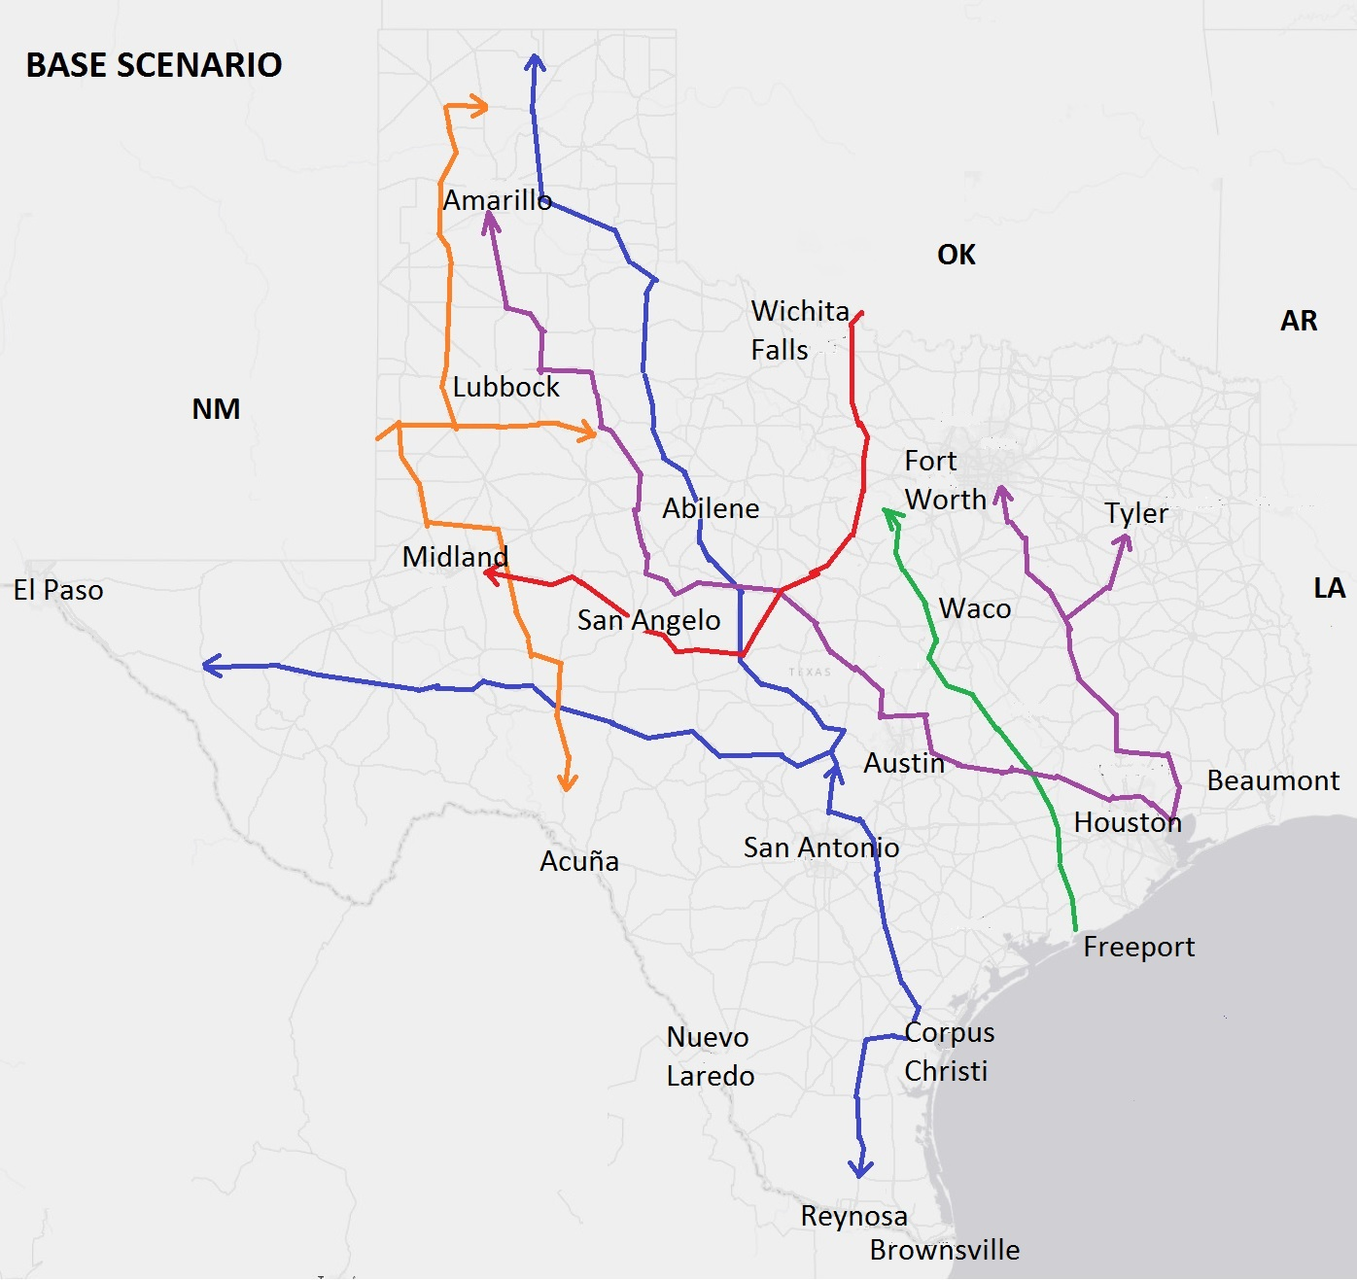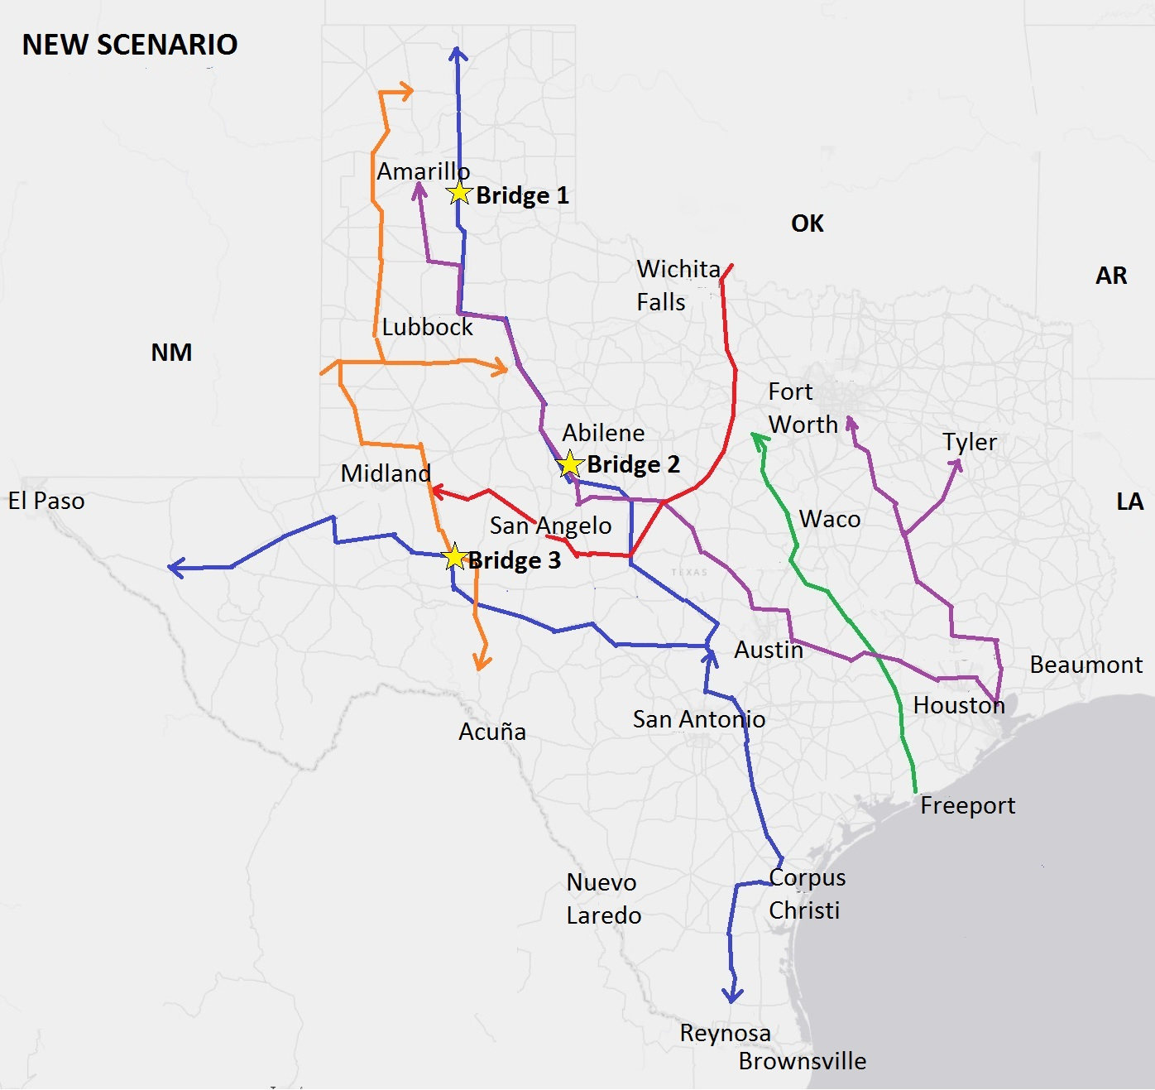

FIGURE 1 Route plans for the different scenarios.

TABLE 1 Prediction Model Results
Variable | Coeff. | t-stat
Constant | -4.336 | -0.52
GDP_{t,t-1} | 0.958 | 2.82
Dlines_{q,t}-Dlines_{q,t-1} | -0.100 | -2.86
RPS_{t} | 8.915 | 2.42
Dummy West Texas – Low WPC | -4.537 | -2.69
Dummy West Texas – High WPC | -6.793 | -2.58
Dummy North Texas | -0.464 | -2.16
Dummy Panhandle | 9.196 | 3.37
w_{q,t-1,t-2} | -0.227 | -3.01
w_{q,t-1,t-2} interacted with:
Dummy non-Central Texas | 0.057 | 1.99
Adjusted R square | 0.32

The dataset is in the public domain and can be obtained here: http://services.arcgis.com/KTcxiTD9dsQw4r7Z/arcgis/rest/services/Freight_Network/FeatureServer/0
As discussed in Uddin et al. (11), heavy loads (such as those involved in the transportation of wind turbine components) damage the pavement more so than less-heavy loads, and this relationship is very non-linear (with pavement damage increasing at a much faster rate than the load factor increase). At the same time, pavement damage due to a given (new) load is higher for a pavement that is already substantially damaged compared to a pavement that is less damaged. In combination, substantial rehabilitation money investments are needed to account for pavement damage due to heavy loads on roads with existing poor pavement conditions relative to on roads with existing good pavement conditions. While a systematic network-based pavement management systems analysis will be needed to optimize corrective/preventive treatments for all damaged pavements, such an analysis is outside the scope of this research. Here, we simply assume that routing heavy loads on less damaged roads is preferable to routing heavy loads on already more damaged roadways.
Additionally, we translated the amount of energy to number of turbines installed. The most common wind turbine installed so far in Texas is the one with a capacity of 1.5MW. So we divided the total amount of energy installed by 1.5 and obtained an approximation of the number of wind turbines installed (if the wind energy production in a Census block group was predicted to be lower than 1.5 MW, the number of turbines in that Census block group was set to zero; this was the case for all urban area Census block groups for all the years). The map with the number of turbines installed can be accessed here: http://arcg.is/1jUvRzW. Additionally, we also computed the space used for wind turbine facilities as a percentage of zone area, using a space need of 5 hectares per turbine installed. The map of percentage of land used for wind farms can be obtained here: http://arcg.is/1OnpehS.
^{,5} Although the number of wind turbines transported through Texas shows an increase each year, the relative percentages of wind energy production across states, and the shares of route origins for shipping turbines, showed reasonable stability over time (based on the dataset listing the permits issued by TxPROS from 2007 to 2009) and formed the basis for the percentages and shares used here. However, these percentages/shares may be modified as appropriate, if more detailed data becomes available to refine the estimates.

